MONDAY EXERCICES

## Q1 HTML Formatting

|  |  |  |
| --- | --- | --- |
| **Tags** | **Display** | **Match** |
| A. <strong>Text here</strong> | 1. Text here | A ……… |
| B. <em> Text here </em> | 2. *Text here* | B ………. |
| C. <del> Text here </del> | 3. **Text here** | C ………. |
| D. <u> Text here </u> | 4. ~~Text here~~ | D ………. |

## Q2 Ordered list

<ol>

<li>Item here</li>

</ol>

|  |  |  |
| --- | --- | --- |
| **Types** | **Display** | **Match** |
| A. list-style:none; | 1/ a. Item here | A ……… |
| B. type=”a”; | 2/ I. Item here | B ………. |
| C. type=”A”; | 3/ 1. Item here | C ………. |
| D. type=”I”; | 4/ Item here | D ………. |
| E. type=”i”; | 5/ A. Item here | E ………. |
| F. type=”1”; | 6/ i. Item here | F ………. |

## Q3 Unordered list

<ul>

<li>Item here</li>

</ul>

|  |  |  |
| --- | --- | --- |
| **Type** | **Display** | **Match** |
| A. list-style:**none**; | 1/ Item here | A ……… |
| B. list-style:**disc**; | 2/ Item here | B ………. |
| C. list-style:**circle**; | 3/ Item here | C ………. |
| D. list-style:**square**; | 4/ Item here | D ………. |

## Q4 Cascading Style Sheets

|  |  |  |
| --- | --- | --- |
| **Type** | **Display** | **Match** |
| A. <link rel=”stylesheet” href=”main.css” /> | 1/ Inline style sheet | A ……… |
| B. <style>  body { background: green; }  </style> | 2/ External style sheet | B ………. |
| C. <h1 style=”color:blue;”>Heading 1</h1> | 3/ Internal style sheet | C ………. |

## Q5 Hyperlinks

A. Write the link from **index.html** to **style.css**

…………………………………………………………………………………………………..

B. Write the link from **index.html** to **teacher.html**

…………………………………………………………………………………………………

C. Write the link from **pnc.html** to **teacher.html**

…………………………………………………………………………………………………

D. Write the link from **pnc.html** to **ronan.jpg**

…………………………………………………………………………………………………

E. Write the link from **teacher.html** to **pnc.jpg**

………………………………………………………………………………………………….

F. Write the link from **teacher.html** to **style.css**

………………………………………………………………………………………………….

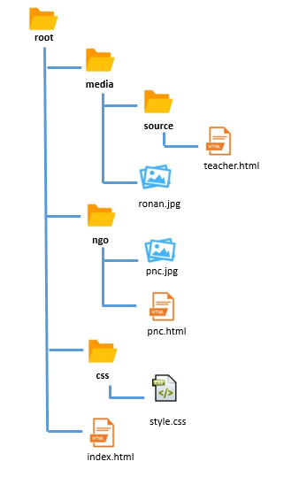

## Q6

Complete the CSS code to fulfill requirements.

|  |  |
| --- | --- |
| HTML | Browser |
| <body>  <a href=”#” >pnc cambodia</a>  </body> | **PNC CAMBODIA** |

|  |
| --- |
| CSS |
| // your code here… |
| Help |
| * The text shall be bold with a sans-serif font |

## Q7

Complete the CSS code to fulfill requirements.

|  |  |
| --- | --- |
| HTML | Browser |
| <body>  <div class=”tealBox”></div>  </body> |  |

|  |
| --- |
| CSS |
| // Your code here… |
| Specifications |
| * The teal box shall be the same width and height [200px] |

## Q8

Complete the CSS code to fulfill requirements.

|  |  |
| --- | --- |
| HTML | Browser |
| <body>  <div id=”circle”></div>  </body> |  |

|  |
| --- |
| CSS |
| // Your code here… |
| Specifications |
| *div circle :*   * The green circle shall be the same width and height [200px] |

## Q9

Complete the CSS code to fulfill requirements.

|  |  |
| --- | --- |
| HTML | Browser |
| <body>  <div class=”orangeBox”></div>  </body> |  |

|  |
| --- |
| CSS |
| // Your code here… |
| Specifications |
| * The text in orange box shall be centered vertically and horizontally * The orange box text shall be bold with a sans-serif font |

## Q10

Complete the CSS code to fulfill requirements.

|  |  |
| --- | --- |
| HTML | Browser |
| <body>  <div class="box one">Box One</div>  <div class="box two">Box Two</div>  <div class="box three">Box Three</div>  </body> |  |

|  |
| --- |
| CSS |
| // Your code here… |
| Help |
| * The all box shall be the same width and height [200px] * The text in all box shall be centered vertically and horizontally * The orange box text shall be bold with a sans-serif font |